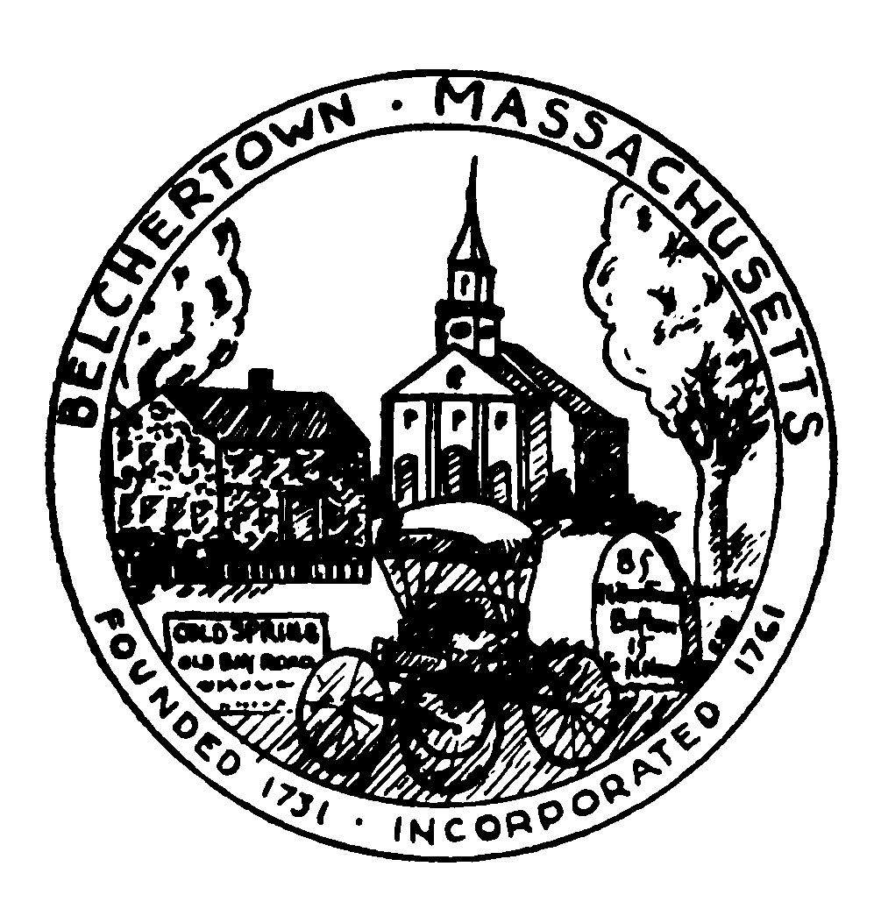
Town of Belchertown
Office of Human Resources
2 Jabish St, Post Office Box 670
Belchertown, MA 01007-0670
Telephone: (413) 323-0412

INTEROFFICE MEMORANDUM

TO: Senior Center Recreation Department
Police Department Clapp Memorial Library
Fire Rescue Department IT Department
Department of Public Works Animal Control Department
School Department Selectboard/Town Administrator

FROM: Human Resources

DATE: July 30, 2026

RE: PLEASE POST INTERNAL & EXTERNAL JOB NOTICE(S)

CONSERVATION ADMINISTRATOR – FULL TIME

The Town of Belchertown is accepting applications for a Conservation Administrator. This full-time position performs responsible, professional, technical, and administrative work in serving as principal staff and advisor to the Conservation Commission, administration and management of Small Municipal Separate Storm Sewer System MS4 General Permit, administering conservation land acquisition and wetlands protection, managing conservation lands and other town properties, conducting environmental reviews, and providing guidance for selected projects by town boards.
Major duties include: Administers and coordinates the local application of the Massachusetts Wetlands Protection Act in conjunction with Belchertown’s Wetland Bylaw; provides public assistance and information on environmental matters, acquisition and management of designated natural resources and conservation lands. Administers and issues storm water bylaw and state standards for storm water design; reviews all submitted applications; issues storm water permits; conducts site visits to monitor work, issues certificates of compliance and updates storm water permits and local regulations. Prepares necessary management plans, legal documents, grant applications and administers those grants received. Prepares long-range plans for land acquisition; conducts onsite inspections of parcels under consideration; negotiates on proposed gifts or purchases of land; Serves as principal staff member to the Conservation Commission and must be available to attend night meetings.
Minimum qualifications: Bachelor’s degree in environmental science or related field; plus two years experience in wetlands management, land conservation, or related field; or any equivalent combination of education and experience. Soil Science Certification, desirable.

The annual salary range for this position is $74,587 - $95,214.

Requests for a job description can be sent to jobs@belchertown.org and applications are available online at www.belchertown.org/human_resources. Application deadline is January 20, 2023.

cc: Town Hall Bulletin Board
Copy Room Bulletin Board

